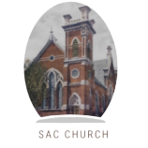 **ST. ANDREW’S-CHALMERS PRESBYTERIAN CHURCH**

**UXBRIDGE, ONTARIO**

**FAITH IN ACTION**

**ISSUE 5 AUGUST 2024**

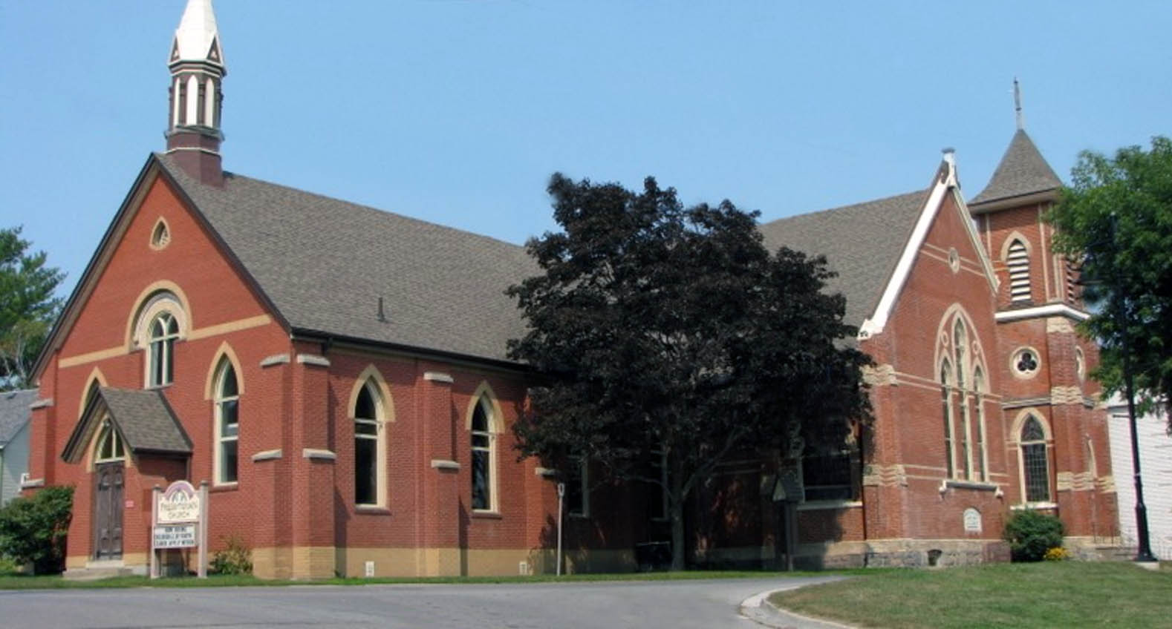

***IN THIS ISSUE:***

**From the Ministers Desk   
by Rev. Sean Astop**

**Working Together in Uxbridge   
by Rev. Sean Astop**

**Bible Readings  
by Joe Ottenhof**

**Reconciliation for Today   
by David Phillips**

**Financial Notes   
by Ian Newton**

**Upcoming Church Events**

**From the Ministers Desk  
By Sean Astop**

Summer is in full swing as evidenced by the wonderful assortment of local fruits and vegetables. Sweet corn, peaches, zucchini, and summer squash, just to name a few. It is important to acknowledge God’s blessings all around us and in the different seasons of our lives. In this 5th edition of the **Faith in Action Newsletter**, you will learn about how our church family has sought to be a blessing locally to Trinity United Church as well as nationally through the Healing and Reconciliation efforts to indigenous peoples through The Presbyterian Church in Canada. You will also be blessed by a Biblical reflection from member, Joe Ottenhof and a report from the Finance Committee. God’s abundant blessings come to us in many ways, may we have eyes to see them this summer and into the fall.

**Working Together in Uxbridge   
By Sean Astop**

Over the past decade our ecumenical relationship with local churches in Uxbridge has been strong. Each week, on Wednesday mornings, the ministers of Uxbridge gather together to pray for our congregations, the community of Uxbridge, and for ourselves as we navigate the joys and challenges of ministry. It is a rich time of self-care and also an important time to discuss the ways we can work together. Over the years we have participated in the One service in June at Elgin Park, in the annual Uxbridge Prayer Breakfast and various prayer and outreach initiatives. Our most consistent relationship has been with Trinity United Church as we have always taken turns hosting Good Friday and often partaking together in the Maundy Thursday Potluck supper.

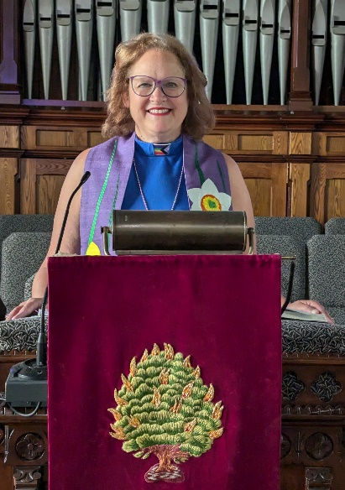

**Working Together in Uxbridge (Contd)**

Recently we have offered Trinity United Church to join our congrgation in the summer as they seek to navigate the challenges of worshiping without a church building. This summer it has been a pleasure to welcome them again and to have Rev. Karen Croxall filling in during my vacation. As we move forward it will be increasingly important to seek opportunities to partner with our friends and neighbours in the Kingdom work, God has called us.

**Bible Readings   
By Joe Ottenhof**

**Running the Race of Life – 1 Corinthians 9:24-27**

I hope you enjoyed the recent Olympic games in Paris as much as we did.

How exciting to experience, at least by our shared Canadian identity, the glory of Summer McIntosh’s swimming triple gold medals. On the other hand, I had to mourn for Damian Warner, our world champion decathlete, who experienced the reality of what 4 years does to a body’s ability to compete against such skilled and much younger competitors. As a lifelong runner, I particularly love track events. So, the gold medal won by our 4x100 meter sprint relay team was incredibly exciting.

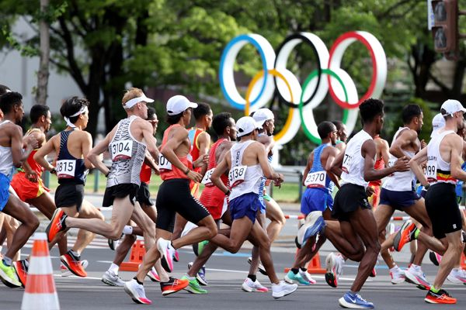

I was thinking of that accomplishment when I sat down to write these Bible notes, and was immediately reminded of 1 Corinthians 9:24-27. It would be good to take a few minutes to read and meditate on these verses if not the whole chapter. This is the passage where Paul compares living our lives to running a race. For most of this chapter he has been establishing his position, as an apostle of the gospel to the Gentiles. Paul makes the case that he is as worthy as the other apostles are to the Jews. Yet he is willing to give up those rights if it means his preaching will be more effective. Paul wants to focus all his energies solely on the goal of winning people everywhere to the message and work of Christ. At the same time, he invites each of us to consider our own race in that regard. Paul encourages us to not run aimlessly or to box without precision, but to remember the imperishable prize that awaits each of us who compete within the rules of the “competition”, that is, our lives. I think Paul is saying that there IS a right way to live and a wrong way.

May we each consider what that means as to how we live our lives and how we interact with the world every day.

**RECONCILIATION FOR TODAY  
By David Phillips**

Over the past several years, there has been a concerted effort to educate the Canadian public about Indigenous issues and the history of these issues.

Residential Schools became a part of the news in this country and in particular, as the Truth and Reconciliation Commission (TRC) did its work. The TRC’s mandate was to inform all Canadians about what happened in residential schools. The TRC met from 2007 until the final event on June 3, 2015. There were seven events across Canada plus the closing event in Ottawa. I attended five of these events including the one in Ottawa. Each one of these was very moving as I had the opportunity to listen to and meet with survivors. Each had a story to tell as some had attended one of The Presbyterian Church in Canada schools. I will never forget these experiences as we not only talked about their experiences in the schools but also about racism today.

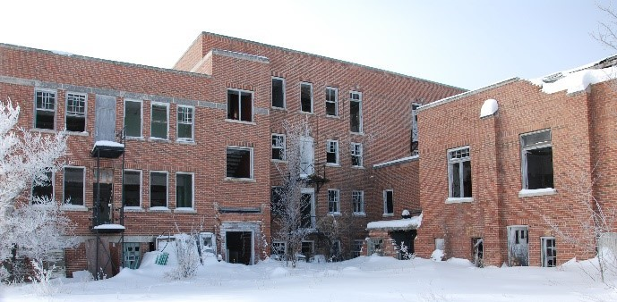

**Birtle Residential School, Presbyterian.**

Residential Schools began in Canada in 1831and the last one closed in 1996. The Presbyterian Church in Canada operated 11 residential schools from Kenora to Vancouver Island.

On September 30th we recognize those that were students or the next generations of those students. That day is Orange Shirt Day and it is the story of a six year old girl who, on the first day at residential school had her new orange shirt, given to her by her grandmother, taken from her. As well, it is the National Day for Truth and Reconciliation, a day to recognize the legacy of residential schools.

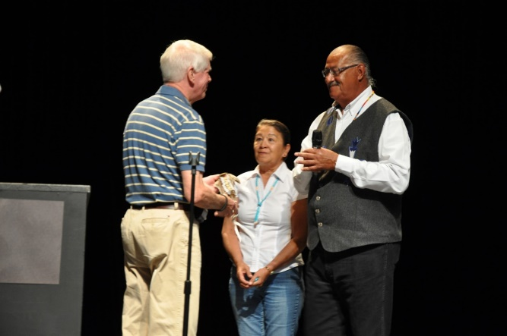

**David Phillips meeting with Eugene Arcade at Canada Youth meeting.**

Reconciliation begins with the recognition that these schools did exist and the suffering continues until today. Please do not say “just get over it” because it is not easy given the trauma suffered.

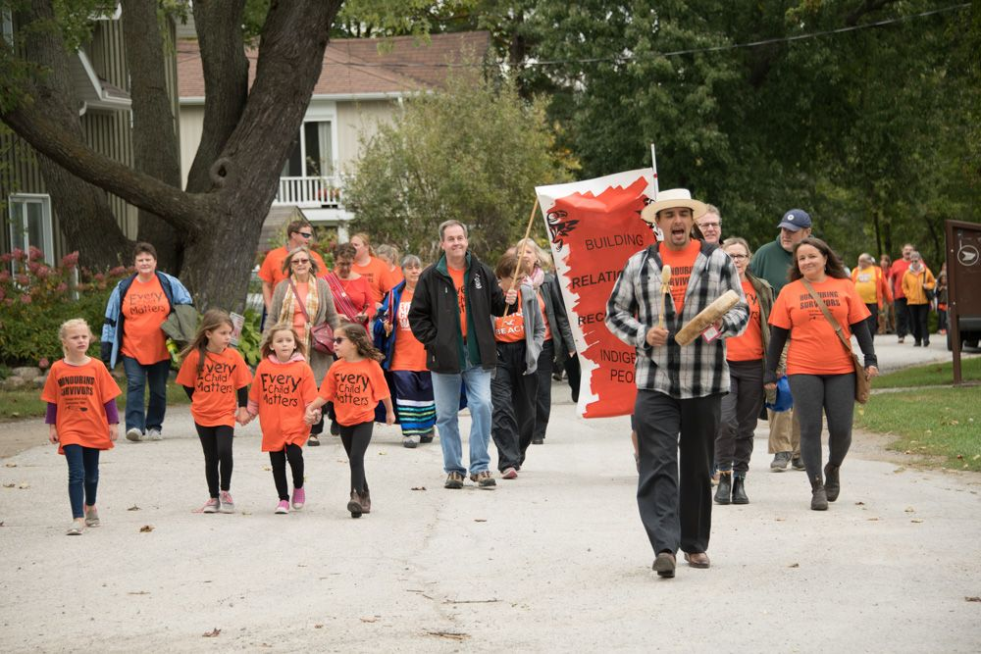

**Orange Shirt Day parade/walk to Elgin Park, Uxbridge**

I can think of an event in childhood that still bothers me in certain situations. Reconciliation begins as we read, watch or listen to stories about Indigenous events and people. Reconciliation begins as we visit a reserve or Indigenous people in their districts. Reconciliation begins when we shut down racism and call to account those people expressing racist comments. Reconciliation begins as we read the 94 Calls to Action and put them into practice. Reconciliation begins when we celebrate the contribution of Indigenous people to our country through many facets of history to the present.

Thank you for taking the time to read this explanation of Canada and the churches’ roles in residential schools and our ongoing need for reconciliation.

**Financial Notes**

**By Ian Newton**

|  |  |  |  |  |  |  |
| --- | --- | --- | --- | --- | --- | --- |
|  | **2024**  **Budget** | **2024 June**  **YTD** | **2024 YE**  **Estimate** | **Diff to YE**  **Budget** | **Comments** |  |
| **Total Income** | **226,500** | **105,232** | **225,832** | **0** | **Excellent giving’s in June** |  |
| **Givings** | **160,000** | **91,075** | **155,976** | **-2%** |  |  |
| **Committees** | **7,200** | **2,939** | **6,771** | **-5%** | **Very well in control on budget** |  |
| **Employment** | **141,362** | **69,210** | **141,360** | **0** | **As budgeted** |  |
| **Total Operating Expenses** | **65,200** | **32,336** | **63,695** | **-2%** | **Well in control** |  |
| **Church Assessment** | **17,000** | **1,709** | **17,429** | **0** | **As budgeted** |  |
| **Surplus/Loss** | **-6,022** | **-957** | **-3,422** | **-43%** | **Better than expected, but deficit expected** |  |

**UPCOMING CHURCH EVENTS**

**Soup Lunch Starts September 4th   
Messy Church September 13th   
Decoration Day @ the Cemetary September 15th @ 2pm  
Knit and Knatter Starts September 19th   
Sharing Sunday September 29th – Karen Plater  
Orange Shirt Day September 30th.  
Wednesdays Morning Coffee 10.30-11.30  
Fridays Men’s Breakfast, 9.00am Hyland Restaurant, in Port Perry.**