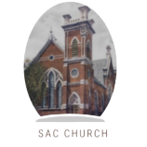

**ST. ANDREW’S-CHALMERS PRESBYTERIAN CHURCH**

**UXBRIDGE, ONTARIO**

**FAITH IN ACTION**

**ISSUE 8 April 2025**

***IN THIS ISSUE:***

**From the Ministers Desk   
by Rev. Sean Astop**

**Bible Notes   
By Joe Ottenhof**

**Building Improvements and Accessibility Project**

**Financial Notes   
by Ian Newton**

**Upcoming Church Events**

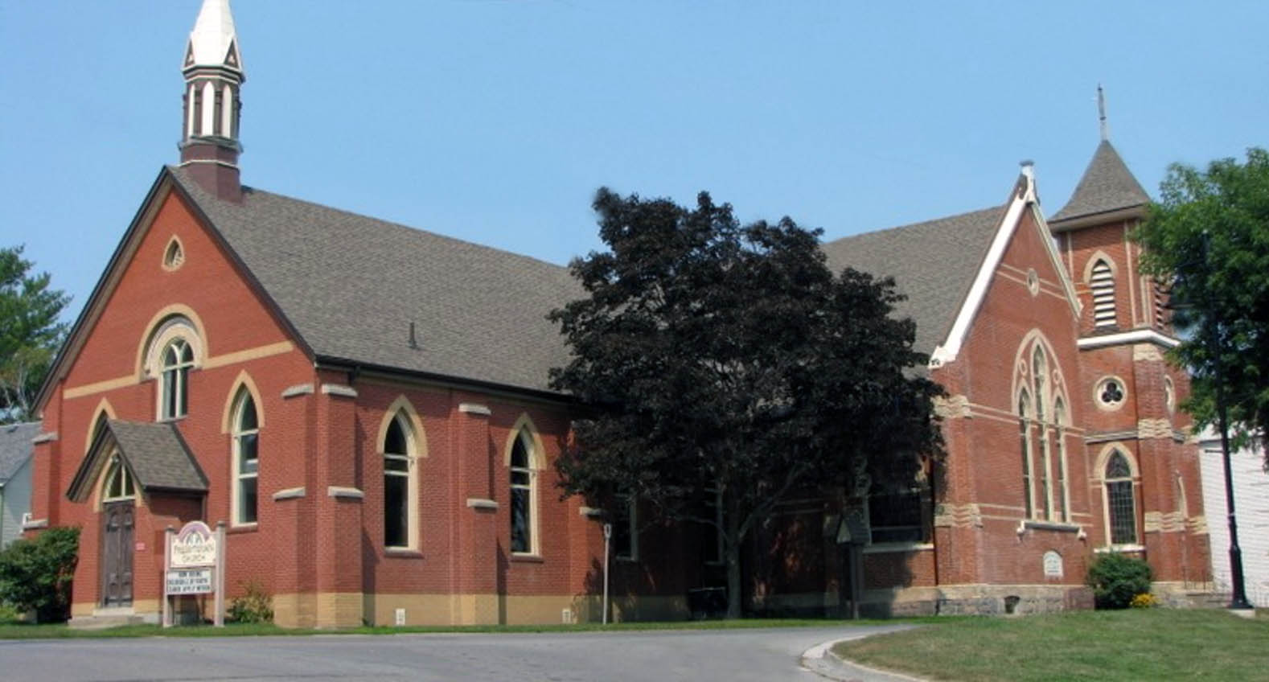

**From the Ministers Desk  
By Sean Astop**

After a long winter that clung on to the bitter end, we welcome the joy and renewal of Easter with open arms! There is something deeply moving about this season—when light stretches further into our days, and hope rises with the promise of resurrection. This Easter, the St. Andrew’s–Chalmers Choir, under the gifted leadership of Elizabeth Cowie, will offer a special musical gift in worship: the *Hallelujah Choir Cantata*. It’s sounding truly amazing, and we can’t wait to share it with you on Easter Sunday. Meanwhile, our Youth Confirmation journey is underway, with seven young people exploring the foundations of our Presbyterian faith and what it means to follow Christ today. Please keep them in your prayers as they grow in faith and community. Our recent Easter Messy Church was a joyful, creative success—thanks to the wonderful volunteers who brought their energy and care. Events like these remind us how meaningful intergenerational ministry can be.

In this Easter edition of *Faith in Action*, you’ll find the second installment of Joe Ottenhof’s thoughtful study on the power and meaning of God’s name—a rich invitation to deepen your understanding of Scripture. You’ll also read about a proposal to update St. Andrew’s Hall. These proposed changes aim to make the space fully accessible and to improve the kitchen facilities—so we can continue to meet the growing needs of the Community Soup Lunch and other vital ministries. I hope this issue brings light to your day, hope to your heart, and a renewed sense that, as a church, we are moving forward together—step by step, and always by grace.

Christ is risen—He is risen indeed!

**Bible Notes by Joe Ottenhof**

***When a Name is not a Name, Part 2***

**   
  
This is Part 2 of a study on the “Shema”, the most recited prayer in Judaism. Previously, we talked about how the name of God is rendered: **יהוה** in the Hebrew bible. In English we render this as YVHV, from which we get the transliteration for the name of God: Yahweh. Theologians call this four Hebrew letter name of God the tetragrammaton. We mentioned that this is God’s name given by God to Moses at the “Burning Bush”. So, why do observant Jews never say the name of God today even though this name, the tetragrammaton, appears in the bible more than 6500 times. When reading the scriptures and coming across the name they will substitute another word Like “Adonai’ or “Lord” or simply say “The Name” in English or “ha Shem” which is Hebrew for “the name”! It is curious because there was no such prohibition among the Jews of the bible themselves. In the book of Ruth 2:4, Ruth is gleaning in the grain field of Boaz who happens upon her. He says to Ruth “ **יהוה** be with you” and Ruth says to Boaz “ **יהוה** be with you”. Using the actual name of God is common in the Old Testament. This prohibition came into being at the time of the Greeks in Israel. The Greeks used incantations and curses using the name of God.

So it became the practice, in order to avoid this desecration of God’s name, that only the priests could say the name of God and only in the temple and only by the High Priest outside the temple on Yom Kippur the most holy day in the Jewish calendar. The ten commandments of course say that we are to not take the name of God in vain, or lightly. Even today many Christians may talk like the proverbial sailor but will rarely say God’s name except in reverence and in context to the name. Personally, I cringe when I hear people say “oh God…” and then complete the sentence with something trivial. Interesting to note that some New Testament theologians say that the justification for the demand that Jesus’ be crucified was that he uttered God’s name during his trial before the Sanhedrin as the high priest tore his robes saying “ You have heard “it”, he has blasphemed”.

In which ever way we take this discussion, let us yearn to be careful with names. How we refer to our children, our partners and our friends and our God, says much about how we see them and the importance they play in our lives

**Building improvements and accessibility project for the Uxbridge Community Soup Lunch and St. Andrew’s-Chalmers Presbyterian Church**

Located in the heart of the downtown, St. Andrew’s-Chalmers Presbyterian is more than a Church. It is a center for community connection, service, and support, as detailed in the paragraphs below.

**The Uxbridge Community Soup Lunch**

This program began in 2011 as an initiative led by the director of North House, who envisioned serving soup at St. Andrew’s-Chalmers Church’s Hall as a way to connect with the community and raise funds for the Food Bank housed in the church basement. North House remained involved until 2016, when a change in leadership prompted a transition. At that point, John Gould, a dedicated member of St. Andrew’s-Chalmers, took the lead, fostering increased community participation and expanding the initiative beyond the church.

In its early stages, local churches including Uxbridge Baptist, Trinity United, St. Paul’s Anglican, Living Water, St. Paul’s Leaskdale, Sacred Heart Catholic, Sandford United, Family Worship Center and St. Andrew’s-Chalmers Presbyterian took turns preparing soup for the community. Over time, participation grew to include a diverse range of community groups, such as the IODE, 1st Uxbridge Scout Group, Shoppers Drug Mart, Vince’s, Uxbridge Public School, Uxbridge Firefighters, individual families, FN Happy Farm, the Rotary Club, the Spice Girls, the Optimist Club, Desjardin Insurance, Caring Crafters, and Mast Creek Harvest Farms. These partnerships have enriched the program, allowing it to serve a greater number of people each week.

The mission of the Uxbridge Community Soup Lunch is to provide a warm, nutritious and affordable meal in a welcoming and supportive environment, addressing both physical and spiritual needs within the community. Beyond nourishment, it fosters social connections and combats isolation, creating a space where individuals can share in fellowship and support. All donations collected during the lunch directly support the Uxbridge Food Bank, with an average contribution of $200 each Wednesday.

**The Growing Need & Our Vision for Expansion**

During the COVID-19 pandemic, the partnership between the Food Bank and St. Andrew’s-Chalmers deepened, as the church hall became a critical space for client services while the basement was used for additional food storage. Post-pandemic, the demand for both the Food Bank and the Community Soup Lunch has surged, with Soup Lunch attendance now reaching up to 70 individuals weekly, including an increasing number of Food Bank clients. This growth has placed additional strain on the existing kitchen facilities, necessitating an expansion and modernization of the space to better serve the community.

To meet this growing need, we are seeking to move forward to secure funding for the following improvements:

* **Kitchen Expansion & Upgrades** – Increased demand requires a more efficient workspace, updated appliances, adherence to Durham Health and an improved prep area to accommodate our volunteers and streamline meal preparation.
* **Accessible Washroom** - To create a more inclusive space, we aim to install a fully accessible, multi-use washroom on the hall level.
* **Main Level to Hall Accessibility Lift** – St. Andrew’s-Chalmers serves as a vital community hub, hosting groups such as the Northern Trails Singing Group, OnStage Theatre, Springtide Music Festival, and various other local arts and cultural events.

The church currently has two ramps: One to enter the sanctuary and a second ramp on the opposite side of the building giving access to the Hall. The only way for clients in wheelchairs or other mobility needs to move from one space to the other is to go outside and around the building.

Installing a lift will provide seamless access between the hall and the sanctuary, ensuring that all members of the community can participate fully in our programs and events.

**St. Andrew’s-Chalmers Presbyterian Church: A Community Hub for Uxbridge**

As we look to the future, we envision St. Andrew’s expanding its role as a true community hub—putting our faith into action by meeting the evolving needs of those around us. Through this project, we have an opportunity to create a more welcoming, accessible, and functional space where people can gather, connect, and receive support.

With your generous support, we can sustain and enhance vital programs, ensuring that no one in our community goes without nourishment, companionship, or access to essential resources. This investment is not just about bricks and mortar—it’s about strengthening our mission, deepening our impact, and building a church that continues to serve as a beacon of hope and hospitality for generations to come. (continued ->)

As a congregation, we deeply value your feedback, prayers, and support for this important project. We invite you to bring your questions and join us for the congregational meeting on April 27th after the service, where we will consider this exciting next step toward a stronger, more connected Uxbridge. Together, we can continue to serve, uplift, and transform lives. Thank you for your support!

**Financial Notes. By Ian Newton**

|  |  |  |  |
| --- | --- | --- | --- |
|  | **2024 YE** | **2025 B** | **Comments** |
| **Total Income** | **215,862** | **229,500** |  |
| **Givings** | **145,567** | **160,000** | **We encourage you to prayerfully consider increasing your givings.** |
| **Committees** | **6,518** | **11,700** | **Increase in organ repairs expected** |
| **Employment** | **138,475** | **138,312** |  |
| **Total Operating Expenses** | **60,014** | **70,400** | **Additional maintenance expenses expected in 2025** |
| **Church Assessment** | **6,779** | **16,900** | **We continue to support PWSD and our outreach** |
| **Surplus/Loss** | **4,078** | **7,812** | **\*\*Due to the mail strike & extension for 2024 offerings in February 2025, the Surplus for 2024 may change** |

**UPCOMING CHURCH EVENTS**



**Sunday March 30 - May 11 – Youth Confirmation @11:45am  
Maundy Thursday April 17 @ 5:30pm Potluck dinner and Last Supper re-enactment   
Good Friday April 18 @ 10am Uxbridge Baptist Church  
Easter Sunday April 20 @ 10:30 am Hallelujah Choir Cantata  
Sunday April 27Congregational Meeting  
Rev. Sean Anniversary Service May 4 @ 10:30am  
Prayer Breakfast (tickets still available) May 14 @ 10:30am hosted at Mill Run Golf Course  
Chime Choir visit May 25 @ 10:30am  
Wednesdays Soup Lunch @ 12 Noon  
Thursday’s @ 1:30pm Knit and Knatter   
Friday Men’s Breakfast @ 9am, Hyland Restaurant, Port Perry  
Spring Church Membership Service**