
ST. ANDREW’S-CHALMERS PRESBYTERIAN CHURCH
UXBRIDGE, ONTARIO
FAITH IN ACTION
ISSUE 10 October 2025
IN THIS ISSUE:
From the Ministers Desk
by Rev. Sean Astop
Bible Notes: By Joe Ottenhof
A Time for Thanksgiving:
By Ian Newton
Fundraising Gala & Donation Numbers
Financial Notes
by Ian Newton
Upcoming Church Events

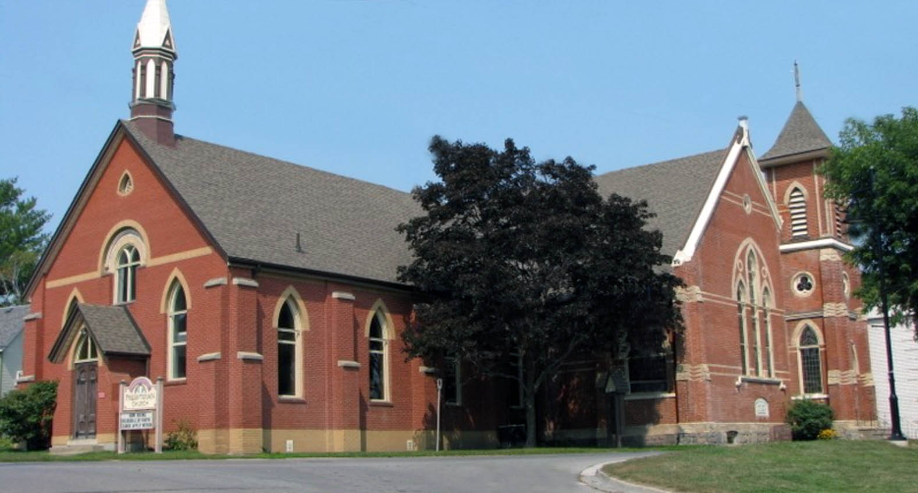
From the Ministers Desk By Sean Astop
Signs of autumn are all around us—the trees bursting with colour, the crispness in the air, farmers hard at work in their fields. With every change of season, we are reminded of God’s faithfulness and the steady rhythm of God's provision.
As we pause to celebrate Thanksgiving, it’s good for us to take time to count our blessings and reflect on God’s goodness. Scripture reminds us in 1 Chronicles 16:34: “O give thanks to the Lord, for he is good; for his steadfast love endures forever!”
As a church community, we truly have much to be thankful for. This summer saw the near-completion of our building project—just awaiting the final inspection. The generosity of our congregation and wider community has been remarkable, making this dream a reality. We’re also grateful that our Community Soup Lunch groups are once again in the kitchen, giving of their time and talents to provide warm meals and fellowship to many in Uxbridge, including some of our most vulnerable neighbours.
To each of you who contributed your prayers, time, resources, and energy—thank you. You are helping to embody the love of Christ in very real and tangible ways.
In this Fall edition of Faith in Action you’ll find:
- A Thanksgiving reflection from Joe Ottenhof
- A financial update from Ian Newton
- Stories of how our ministries continue to make a difference in the lives of others
As you read, I hope you’ll be reminded of the many ways God is at work among us, and how blessed we are to live in Uxbridge and to be part of such a caring church family and community.
May this season of thanksgiving fill your heart with gratitude and hope.
With every blessing,
Rev. Sean Astop

🍁 Bible Notes on Thanksgiving
By: Joe Ottenhof
Each year, as the season turns, we’re encouraged to gather with family and friends to reflect on what we have—and to express our personal and collective gratitude.
In our family, this tradition often includes a familiar question around the dinner table—usually with pumpkin or apple pie just inches from our mouths: “What are you most thankful for this year?”

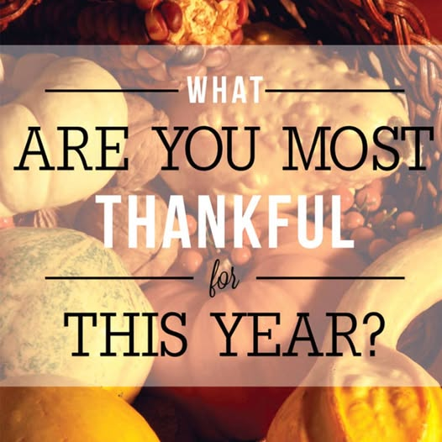
The responses, while sometimes predictable, are always heartfelt. They’re deeply appreciated by parents and grandparents, and warmly received by husbands, wives, sisters, and brothers alike.
The Bible, from Genesis to Revelation, is rich with the theme of thanksgiving. It’s not always the kind we associate with a “celebration of plenty” like our annual feast here in Canada, but it’s certainly worth “hearty consumption” nonetheless.
Here are two well-known verses on thanksgiving—think of these reflections as the whipped cream on your pumpkin pie. 😊
🙏 1 Thessalonians 5:16–18 (NASB)
“Rejoice always, pray without ceasing, in everything give thanks; for this is the will of God for you in Christ Jesus.”
Paul wrote much of the New Testament from a Roman jail cell—a place he landed because of his unwavering commitment to Jesus and his proclamation of the Kingdom of God.
He encourages us to give thanks in all things—not necessarily for all things.
By God’s grace, may we learn to see the good beyond our present circumstances, both in our lives and in the lives of those around us.
🎁 2 Corinthians 9:15
“Thanks be to God for His indescribable gift.”
This verse follows Paul’s gratitude toward the Corinthian church for their generous financial support of the Gospel’s spread.
It reminds us that our giving should flow from thanksgiving for what God has already done for us in Christ.
As followers of Jesus, generosity should mark our lives—not as a means to gain, but as a response to the abundance we’ve already received and continue to experience through Him.



May your celebration be filled with joy, reflection, and a deep sense of gratitude—for the blessings seen and unseen, shared and still unfolding.

A Time for Thanksgiving by Ian Newton

As we welcome the beauty of autumn, I was reminded—while out walking the dog on a clear, crisp day—just how fortunate we are to call Canada home. We live in a peaceful corner of the world, blessed with quiet and security, even while conflict and hardship continue to affect so many regions abroad. Look at the Middle East, Ukraine, Sudan with 12 million displaced, Myanmar, Nepal, and on and on.
Canada’s foundation as a tolerant and diverse nation has shaped the society we live in today. Despite political divides, our differences remain relatively narrow, and here in Southern Ontario we have much to be thankful for. Even as we face economic challenges and uncertainty, our community continues to show resilience and generosity.
Closer to home in Uxbridge, we are especially grateful for the progress and vitality within St. Andrew’s Chalmers Church. Over the past year, we have seen growth in our congregation, with more families attending regularly and youth becoming more deeply involved—including youth communion. Programs like Messy Church, Knit and Knatter, Wednesday Soup lunches, Volleyball, Pickleball, location for the Uxbridge Food Bank, and other outreach initiatives have continued to thrive.
Our church has also made significant strides in supporting the wider community. From contributing to education in a local high school in Guatemala, the Jennifer Ashleigh Children’s Charity, to engaging with Indigenous community initiatives in Winnipeg, our outreach has touched lives near and far. Significant donations were also made to Doctors without Borders, Canadian Grains Food Bank and Africycle. Our biggest initiative, the Building and Accessibility Project, nearing completion, totaling nearly $300,000—a milestone made possible through incredible donations, dedication, and countless volunteer hours.
As we celebrate Thanksgiving, let us pause to reflect on the blessings around us—our families, our community, and the opportunities to come together in faith and generosity.
Fundraising Gala @ St. Andrew’s-Chalmers
We are deeply grateful for the incredible support we’ve received for the renovations at St. Andrew’s-Chalmers.
Thanks to the generosity of our congregation, we have raised an impressive $44,965, which has been matched by the Memorial Fund up to $44,000. In addition, our wider community has contributed an outstanding $48,050, with the Jerico Foundation graciously matching this amount up to $50,000.
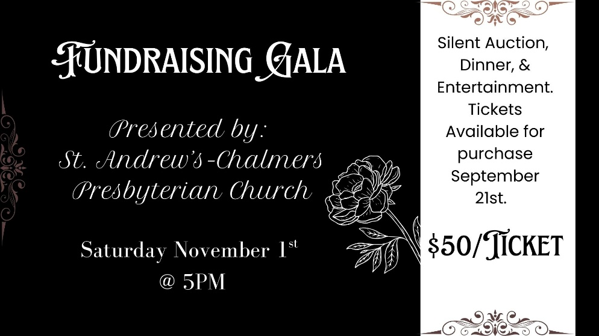
We’re so grateful for everyone who helped make this possible—your support is helping bring our renovation project at St. Andrew’s-Chalmers to life!
To continue our fundraising efforts, we’re excited to host a Gala Evening on Saturday, November 1st, featuring a silent auction with items donated by local businesses, along with great food, entertainment, and community spirit. Thank you for being part of this journey with us!

Financial Notes: By Ian Newton
 | 2025 Budget | First Half Budget | First Half Actual | 2025 YE Estimate | Comments
Total Income | 229,500 | 109,466 | 106,643 | 222,173 | Hopefully will be close to budget by year end.
Givings | 160,000 | 74,720 | 73,942 | 159,722 | Wonderful increase in our Givings, thank you for your support.
Committees | 11,700 | 5,846 | 2,538 | 8,393 | Under budget and thank you to all chairpersons.
Employment | 138,312 | 69,156 | 69,688 | 138,842 | On budget
Total Operating Expenses | 70,400 | 35,194 | 33,372 | 68,580 | Close to budget by year end.
Church Assessment | 16,900 | 1,200 | 1,200 | 2,400 | We continue to support PWSD and our mission outreach
Surplus/Loss | -7,812 | -1,930 | $156 | 8,688 | Very much dependent on income/Givings during the year. We expect to be improved over our budgeted loss.

UPCOMING CHURCH EVENTS

October 24 – Messy Church @ 5:45pm
November 1st – Fundraising Gala @ 5pm Tickets SOLD OUT!
November 2nd – Anniversary/Building Celebration Service
November 9th – Rememberance Day Service
November 30th – First Sunday of Advent
Wednesdays Soup Lunch @ 12 Noon
Thursday’s @ 1pm Knit and Knatter Resumes October 2nd
Friday Men’s Breakfast @ 9am, Hyland Restaurant, Port Perry

